**Completed Tasks**

1. Purchase ticket
2. Approve buyer
3. Account Creation

**Pending Tasks**

1. Ticket creation
2. Sell the ticket

**Important Points**

1. there is no need of input field for approve functionality as address of buyer is taken from the backend logic.
2. should I do same for the sell functionality where I take buyer address from the approvedBuyers mapping if yes then create a function to get the approved buyer address.
3. Now UI will update automatically.
4. How to manage the ticket creation ? for now there are fix 7 tickets which are created from the constructor.

**Note: I commented the NewAccount event in the accountCreation function as it produces the error**

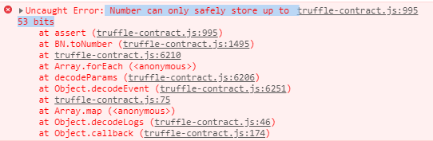

**emit event of account creation won't work with stringand indexed combination**

Please refer this link and resolve the problem this problem will also occur for ticket creation

[https://ethereum.stackexchange.com/questions/6840/indexed-event-with-string-not-getting-logged/7170#7170](https://ethereum.stackexchange.com/questions/6840/indexed-event-with-string-not-getting-logged/7170" \l "7170)